CS 255 System Design Document Template

UML Diagrams

UML Use Case Diagram

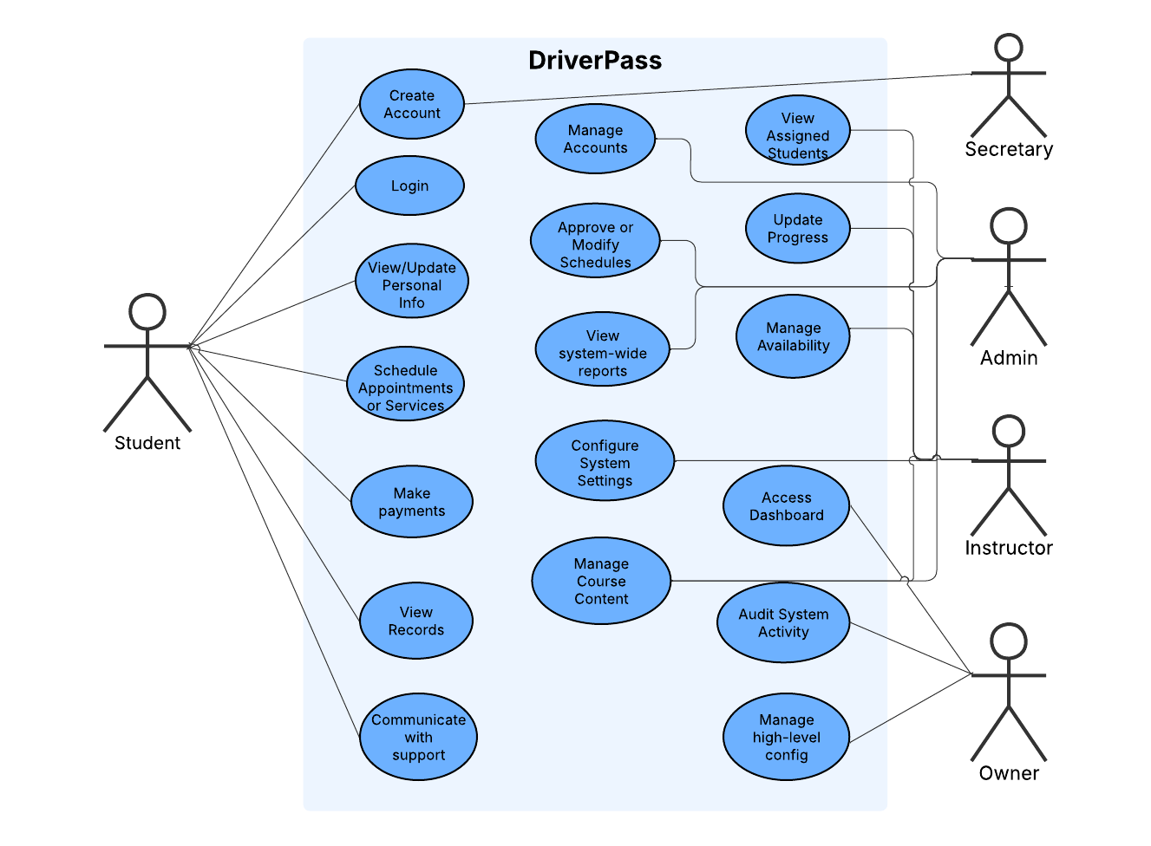

UML Activity Diagrams

Reservation Activity Diagram

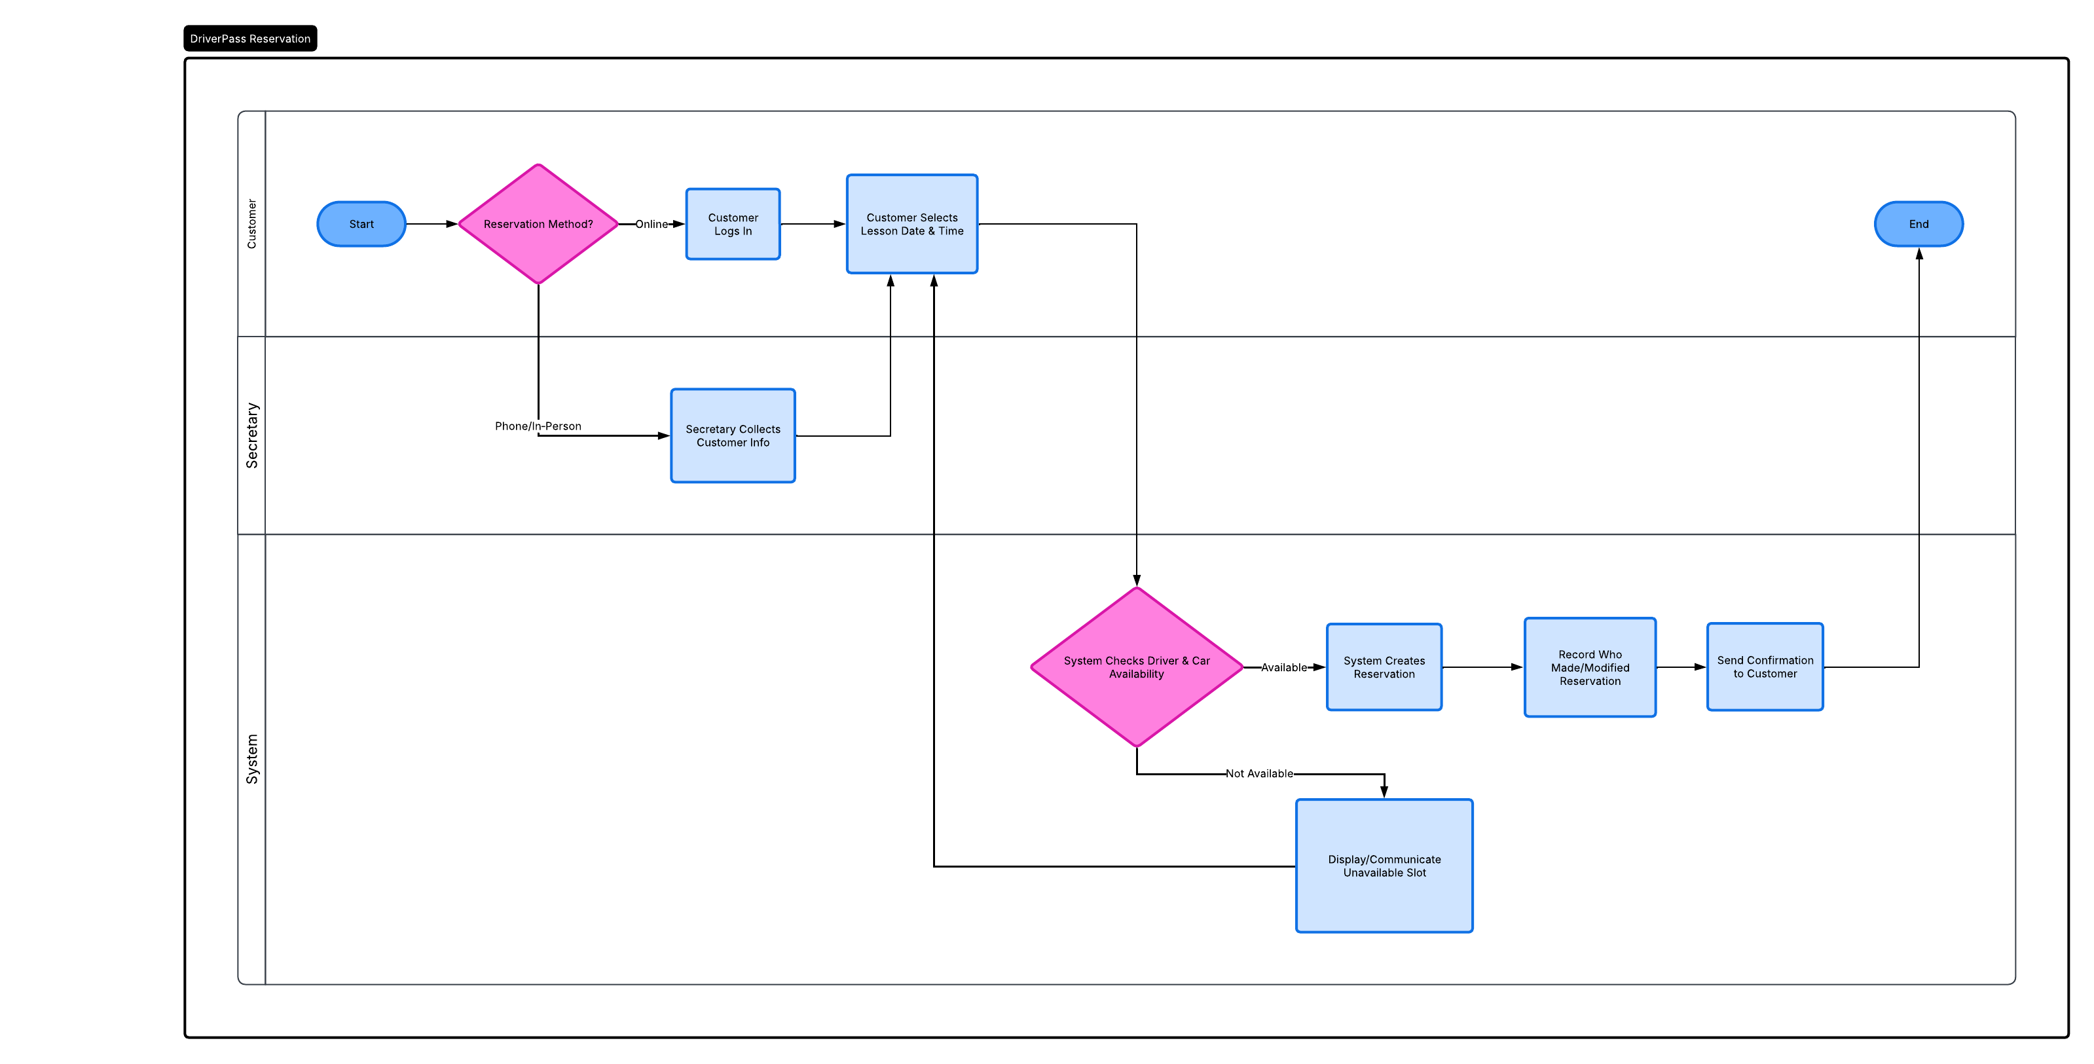

User Registration Activity Diagram

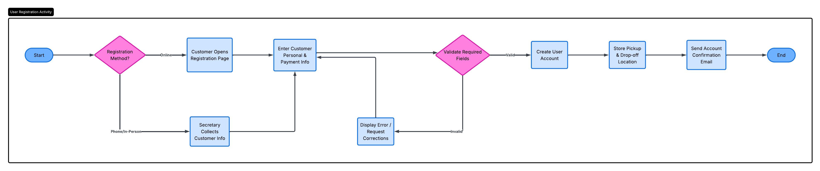

UML Sequence Diagram

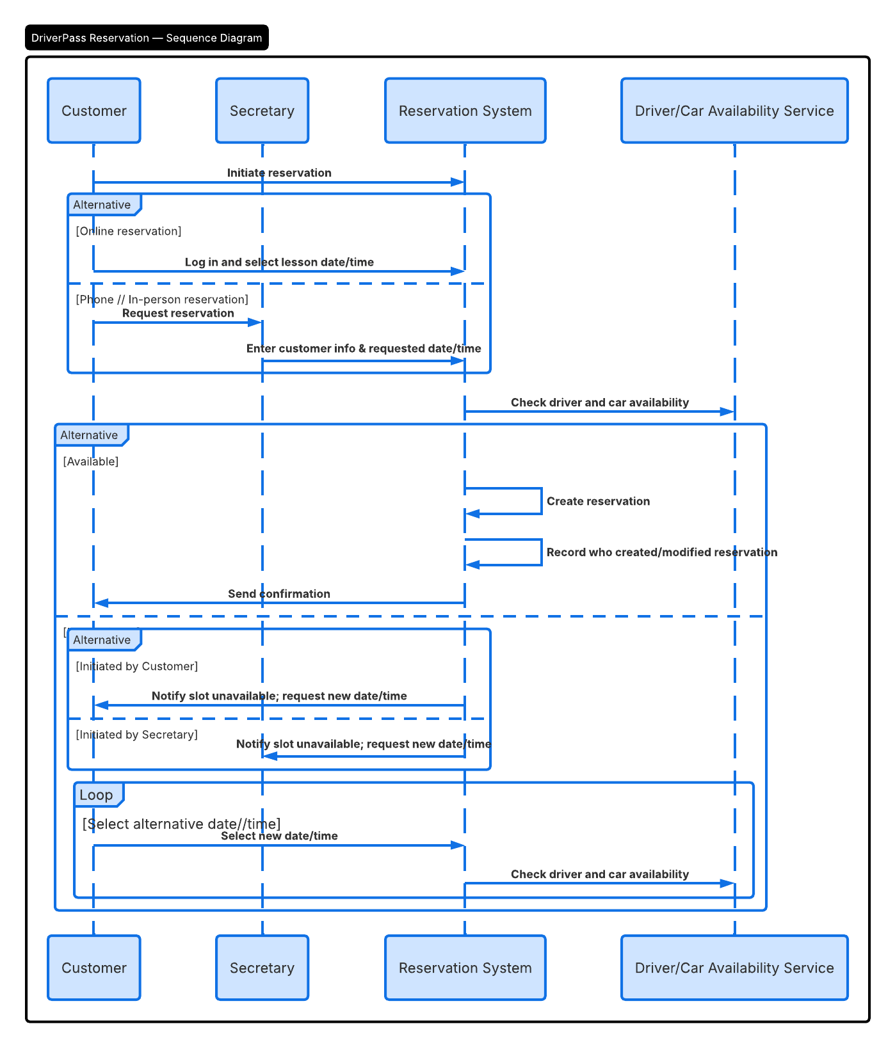

UML Class Diagram

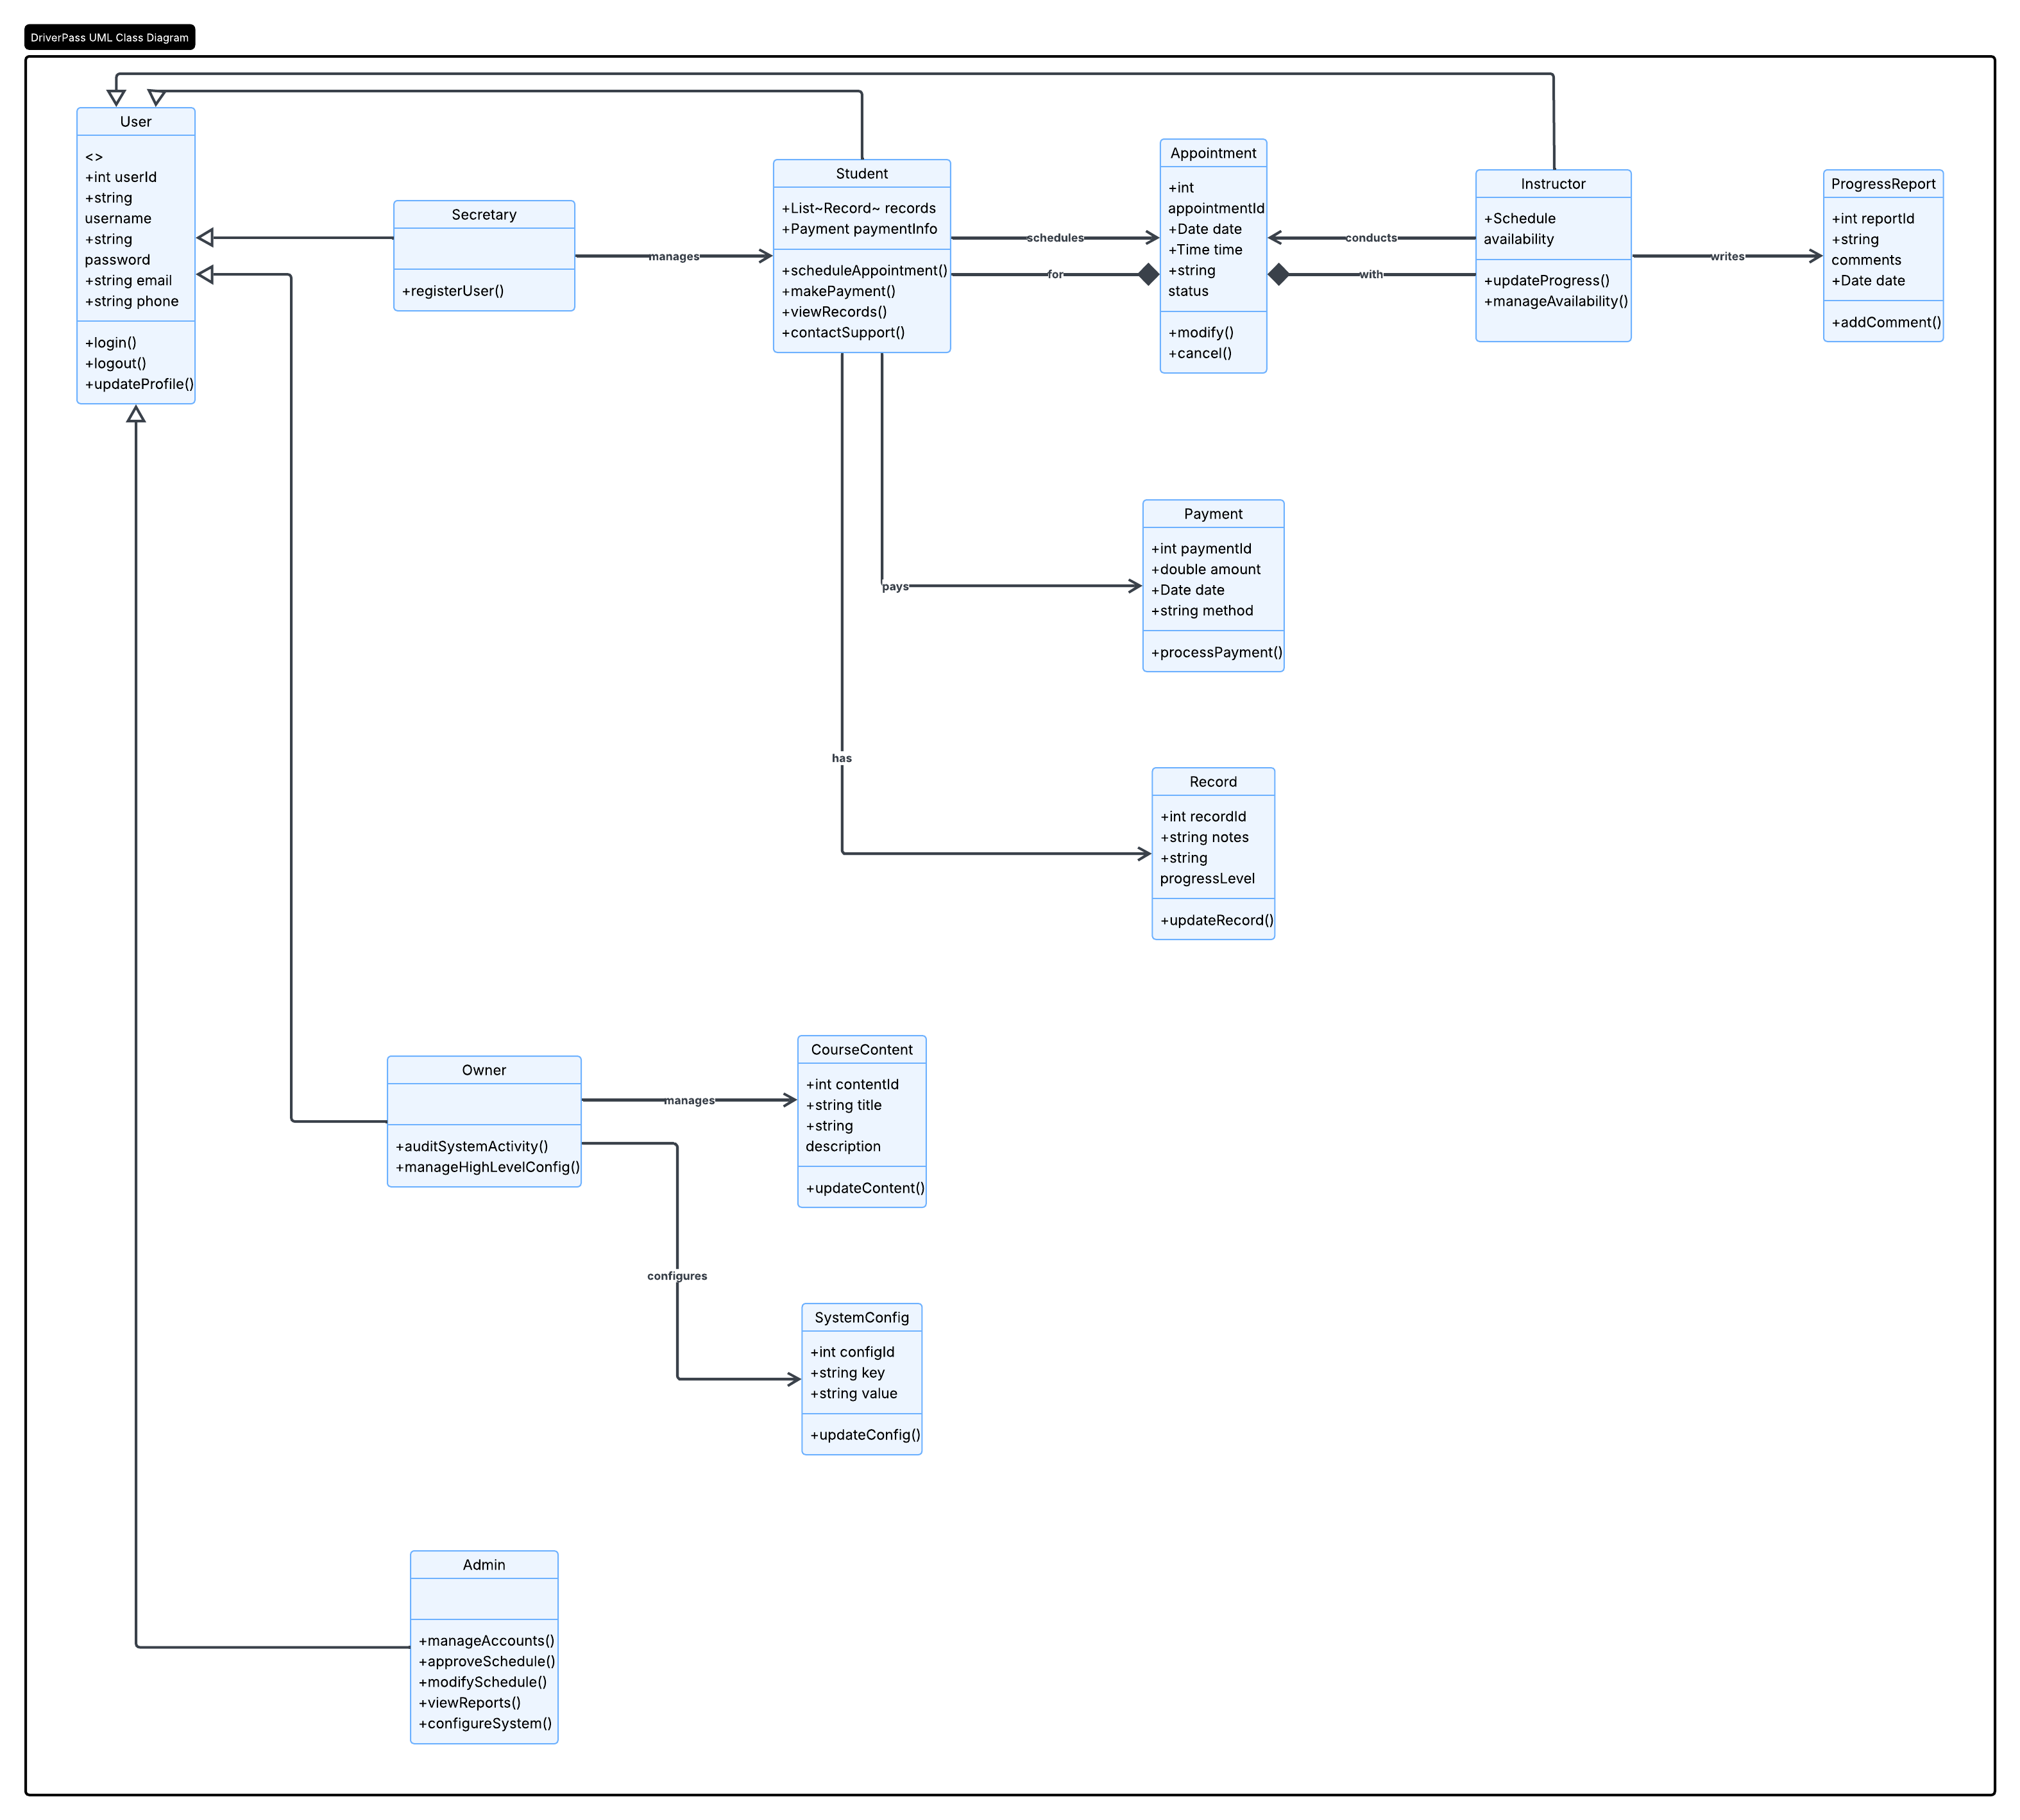

Technical Requirements

1. Hardware Requirements
Client-Side (Students, Secretary, Owner, IT Officer)
The system must run on any computer or mobile device capable of accessing the web:
- Desktop or laptop (Windows, macOS, Linux)
- Smartphones and tablets (iOS, Android)
- Basic hardware:
  - Internet connection
  - Modern web browser
  - Ability to download reports (Excel files)
Transcript basis:
Liam: “I want to access data online from any computer or mobile device.”
Liam: “I need to be able to download the reports… using Excel.”

Server-Side Hardware
Because the system must run “off the web” and “preferably over the cloud,” the hardware will be cloud-hosted:
- Cloud-based virtual machines or containers
- Scalable CPU/RAM depending on traffic
- Cloud storage for:
  - Student records
  - Appointments
  - Packages
  - DMV updates
  - Online class content
  - Practice tests
Transcript basis:
Ian: “The system needs to run off the web, preferably over the cloud.”

2. Software Requirements
Client-Facing Software
- Web browser supporting HTML5, CSS3, JavaScript
- Excel or compatible spreadsheet software (for downloaded reports)
Server-Side Software
To meet the system’s needs:
Core Application
- Web application framework (e.g., Java Spring Boot, .NET, Node.js)
- REST API for mobile/desktop access
- Authentication & authorization system (role-based)
Transcript basis:
Ian: “We have different employees… with different rights and roles.”
Database
A relational database is required to store:
- Student information
- Packages
- Appointments
- Cars and drivers
- Online test results
- DMV updates
- Activity logs (audit trail)
Suitable DBMS options:
- PostgreSQL
- MySQL
- SQL Server
Transcript basis:
Liam: “I need to make sure I know who made a reservation, who canceled it, who modified it last.”
Security Software
- Role-based access control
- Password reset automation
- Logging and audit trail system
- HTTPS/TLS encryption
- Cloud-managed backups
Transcript basis:
Ian: “I need to have full access… reset accounts… block access.”
Liam: “I need to make sure I know who made a reservation… print an activity report.”
Integration Software
- API integration with DMV systems for:
  - Rule updates
  - Policy changes
  - Sample questions
- Notification system for DMV updates
Transcript basis:
Liam: “We need to be connected to the DMV so they can update us… We should get a notification whenever they have an update.”
Online Learning Platform Components
- Content management for online classes
- Practice test engine
- Progress tracking dashboard
Transcript basis:
Liam: “I want them to be able to take online classes and practice tests.”

3. Tools Required
Development Tools
- IDE (IntelliJ, VS Code, Eclipse, Visual Studio)
- Version control (Git)
- UML modeling tools (Lucidchart, Draw.io)
- API testing tools (Postman, Swagger UI)
Project Management Tools
- Gantt chart software
- Task tracking (Jira, Trello, Azure DevOps)
Transcript basis:
Sam & Jennifer discuss scheduling, dependencies, and Gantt chart creation.

Testing Tools
- Automated testing framework (JUnit, Selenium, Cypress)
- Load testing (JMeter)
- Security testing tools
Deployment Tools
- Cloud deployment platform (AWS, Azure, GCP)
- CI/CD pipeline (GitHub Actions, Azure DevOps, Jenkins)

4. Infrastructure Requirements
Cloud Infrastructure
- Web hosting environment
- Database hosting
- Storage for:
  - Course content
  - DMV updates
  - Reports
  - Logs
- Automated backups
- High availability and redundancy
Transcript basis:
Ian: “We do not want to deal with backup and security; we need that to be taken care of.”

Networking
- Secure HTTPS access
- Firewall and intrusion detection
- API gateway for DMV integration

Scalability
- Ability to add new packages in the future
- Ability to disable packages without removing them
- Support for increasing numbers of students, cars, and instructors
Transcript basis:
Liam: “I would like to be able to customize these packages… disable a package.”

5. Functional Infrastructure Requirements
User Roles
From transcript:
- Owner (Liam) – full visibility, reporting
- IT Officer (Ian) – system maintenance, account resets
- Secretary – scheduling, customer registration
- Customer/Student – online scheduling, tests, progress tracking
- Drivers/Instructors – lesson notes, availability

